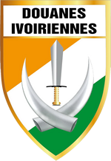
OMD-AOC
“4th meeting of the Regional Working Group on IT Development of WCO Region of West and Central Africa (WCA),
Republic of Côte d'Ivoire
6, 7, 8, 9 March 2018”

FORM OF COLLECTION OF THE ADMINISTRATION ACTIVITIES OF THE WCO-WCA REGION

COUNTRY :

ACTIONS UNDERTAKEN IN THE IMPLEMENTATION OF THE 2017 WCO SLOGAN
Actions | Objective | Results | Observations

ACTIONS UNDERTAKEN IN THE IMPLEMENTATION OF THE 2017 WCO SLOGAN
Actions | Objective | Results | Observations

COLLECTION OF CONCERNS FOR THE 2018 MUTUALITY GROUP
CONCERNS | Observations

